Evaluation of Net Efficacy as a Physical Barrier Against Drosophila suzukii in Grapevines.

By Matteo Tarquini and Belinda Kemp, Niab.

1. Introduction
Drosophila suzukii (spotted wing drosophila - SWD) is a major pest of berry crops due to its ability to oviposit in ripening fruit, causing significant economic losses. In viticulture, the development of non-chemical control strategies is increasingly important within integrated pest management (IPM) programmes. This trial evaluated the efficacy of a physical barrier net applied to the fruiting zone to reduce D. suzukii infestation and assessed its potential effects on grape juice standard chemical composition at harvest.

2. Objective
The objectives of this trial were:
- To assess whether an insect-proof net (0.8 mm mesh) reduces the emergence of adult Drosophila suzukii at harvest.
- To evaluate whether net application affects grape ripening and juice chemical parameters.
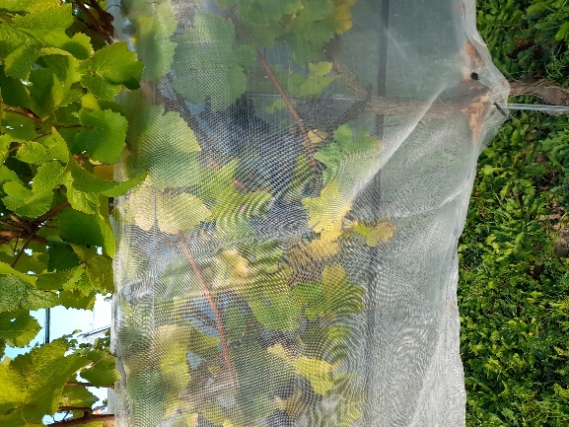
Figure 1. The white SWD net application in the trial plots. It provided protection against both SWD and birds.

3. Materials and Methods

3.1 Experimental Design
The trial compared insect-proof netting with commercial standard management practices:
- Insect-proof netting (referred to as the white treatment)
- Control, commercial standard (referred to as the blue treatment)
Each treatment was arranged in three replicated plots.
Within each replicate, two samples were collected from two different locations within the same plot, to account for spatial variability.
- Treatments: 2
- Biological replicates per treatment: 3
- Samples per replicate: 2
- Total samples per treatment: 6
The experimental unit was the plot (replicate). Subsamples were used to improve sampling reliability and were averaged at replicate level for interpretation.

3.2 Crop, Site and Net Application
The trial was conducted at Niab East Malling on grapevine (Vitis vinifera L.) Pinot Noir clone 114 grafted on rootstock 420A, planted in 2019.
The treatment consisted of protecting the fruiting zone with an insect-proof net, applied at the onset of véraison.
Netting was supplied by Vineworks Ltd and consisted of a small white mesh (0.8 mm x 0.8 mm HDPE U.V. Monofilament 75 g m²). The net was applied on the 12 August 2025 and manually positioned around the grape bunch zone, acting as a physical barrier to limit D. suzukii access. It remained in place until harvest. The insect-proof netting was installed using a combination of pin clips and staples to adequately seal the edges and prevent the entry of flies (see Figure 2a). The control plots were covered at the same time using a large-mesh bird net; made with High Density Polyethylene 30 g m² supplied by Agrii. However, this type of net cannot protect fruit against SWD. The tested white netting was also effective as an anti-feeding bird net.
Control plots received an insecticide spray on 12 September 2025 using Spinosad as the active ingredient, which is also reported to be effective against SWD adults. No insecticide spray was applied to the insect-proof netting plots.
Fig. 2a. Fig. 2b.
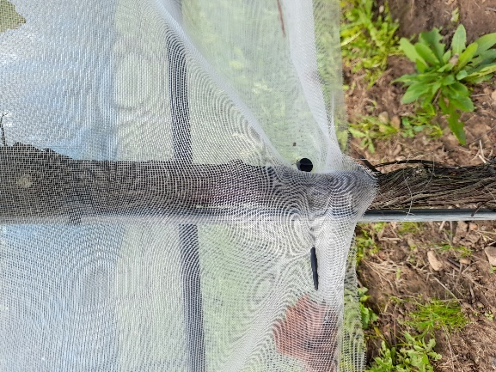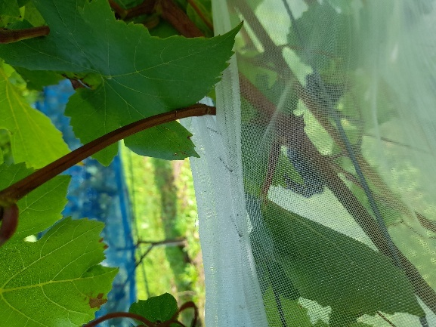
Figure 2a & 2b. The system used to seal the edge of the net to prevent the entry of flies, using a combination of plastic pins and staples.
Figure 3. Experimental field design.

3.3 Grape Sampling and Drosophila suzukii Assessment
Two samples were collected: one consisted of 10 bunches randomly taken from each plot to analyse the must, and the other consisted of nine grape bunches randomly collected within the fruiting zone of each replicate bay. Both samples were collected on 24 September 2025 (harvest). Samples for SWD were immediately incubated in sealed, breathable containers provided by the Entomology Department at Niab until 8 October 2025. The incubation stage is fundamental because it allows the eggs and larvae of SWD to develop and emerge as adults, facilitating their counting.
Grape bunches were incubated at approximately 20 °C for 14 days, then frozen and adult D. suzukii were counted (see Figure 4).
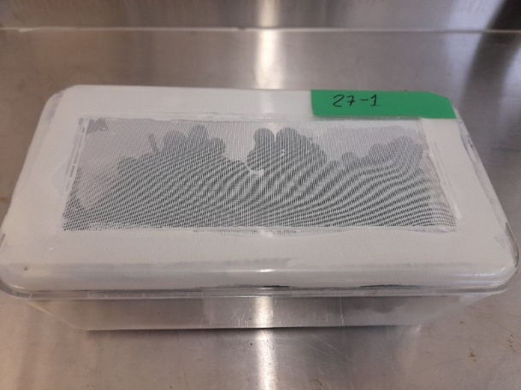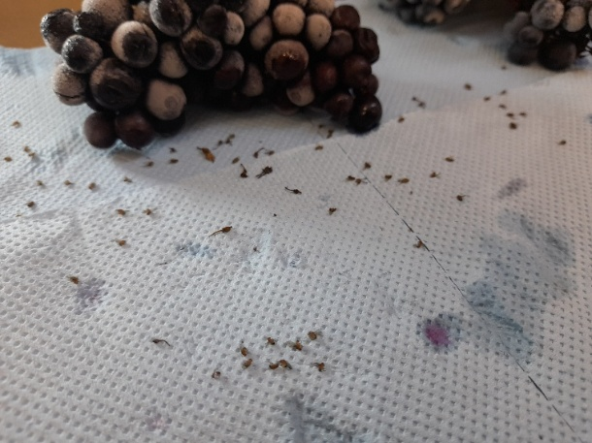
Figure 4. The images above show the sealed containers used and the deceased SWD adults ready to count.

3.4 Juice Analysis
Juice samples were analysed for:
- °Brix
- Specific gravity (SG)
- pH
- Titratable acidity (TA g/L)
- L-malic acid (g/L)
- Ammonium (NH₄⁺)
- Primary amino acids (mg N/L)
- YAN (mg N/L)
Statistical comparisons between treatments were performed using two-sample t-test (α = 0.05).

4. Results

4.1 Drosophila suzukii Emergence
Mean adult emergence per replicate every 9 bunches:
- Netted plots: 2.0 adults
- Non-netted plots: 6.0 adults
This represents an approximate 66% reduction in adult emergence in netted plots.
t-test on replicate means:
- t = −2.62
- df ≈ 3.2
- p = 0.074
The effect was not statistically significant at 5%.

4.2 Juice Analysis Results
Mean values per treatment (n = 6 samples per treatment). The samples were analysed using the SPICA Biosystem for YAN (mg N/L) (PAN mg N/L, ammonium mg N /L), Malic acid (g/L). °Brix and specific gravity were carried out using the Anton Parr Density meter, and pH and TA (as tartaric acid equivalents g/L) by manual titration to an end point of pH 8.2.
Table 1. Chemical analysis of Pinot noir juice from both treatments.
Parameter | Insect-proof netting (white) | Control (blue) | p-value
°Brix | 20.8 | 20.9 | 0.81
Specific gravity | 1.086 | 1.087 | 0.67
pH | 3.26 | 3.24 | 0.49
Titratable acidity (g/L) | 10.2 | 11.3 | 0.031
L-malic acid (g/L) | 5.2 | 5.6 | 0.18
Ammonium (mg N/L) | 38.3 | 51.8 | 0.13
PAN (mg N/L) | 77.3 | 83.7 | 0.58
YAN (mg N/L) | 100.3 | 126.3 | 0.071

Data interpretation
- No significant differences were observed for °Brix, pH or density, indicating that Insect-proof netting application did not delay ripening.
- TA (g/L) was significantly lower in Insect-proof netting (p < 0.05).
- YAN was lower in Insect-proof netting, showing a significant trend at the 10% level.

5. Discussion
The Insect-proof netting substantially reduced Drosophila suzukii emergence, confirming the effectiveness of the net as a physical barrier. Although statistical significance at 5% was not achieved for insect counts, the magnitude and consistency of the reduction indicate a biologically meaningful effect.
Must analysis showed that netting did not negatively affect grape ripening, as sugar accumulation and pH were unaffected. The observed reduction in TA (g/L) and the tendency towards lower YAN in netted plots suggest a microclimatic effect within the fruiting zone, possibly related to modified temperature and radiation conditions.
Statistical results should be interpreted with caution, as samples represent subsampling within three biological replicates. Nevertheless, there is consistency of the trends supports the robustness of the conclusions.

6. Conclusions
- Insect-proof netting reduced Drosophila suzukii adult emergence by approximately 66%.
- No negative effects on ripening parameters were observed.
- Insect-proof netting influenced some juice composition parameters (TA and YAN), likely due to microclimatic modification.
- The insect-proof net tested represents a promising non-chemical IPM tool for vineyard systems depending on costs per hectare for the netting, and labour costs for application (although these costs will likely be similar to those for bird netting application).
- Further trials with increased replication are recommended to strengthen statistical power.
- This type of insect-proof netting requires a more specific and faster sealing system. Using pins and staples takes a lot of time, which would not be feasible for larger vineyards.

